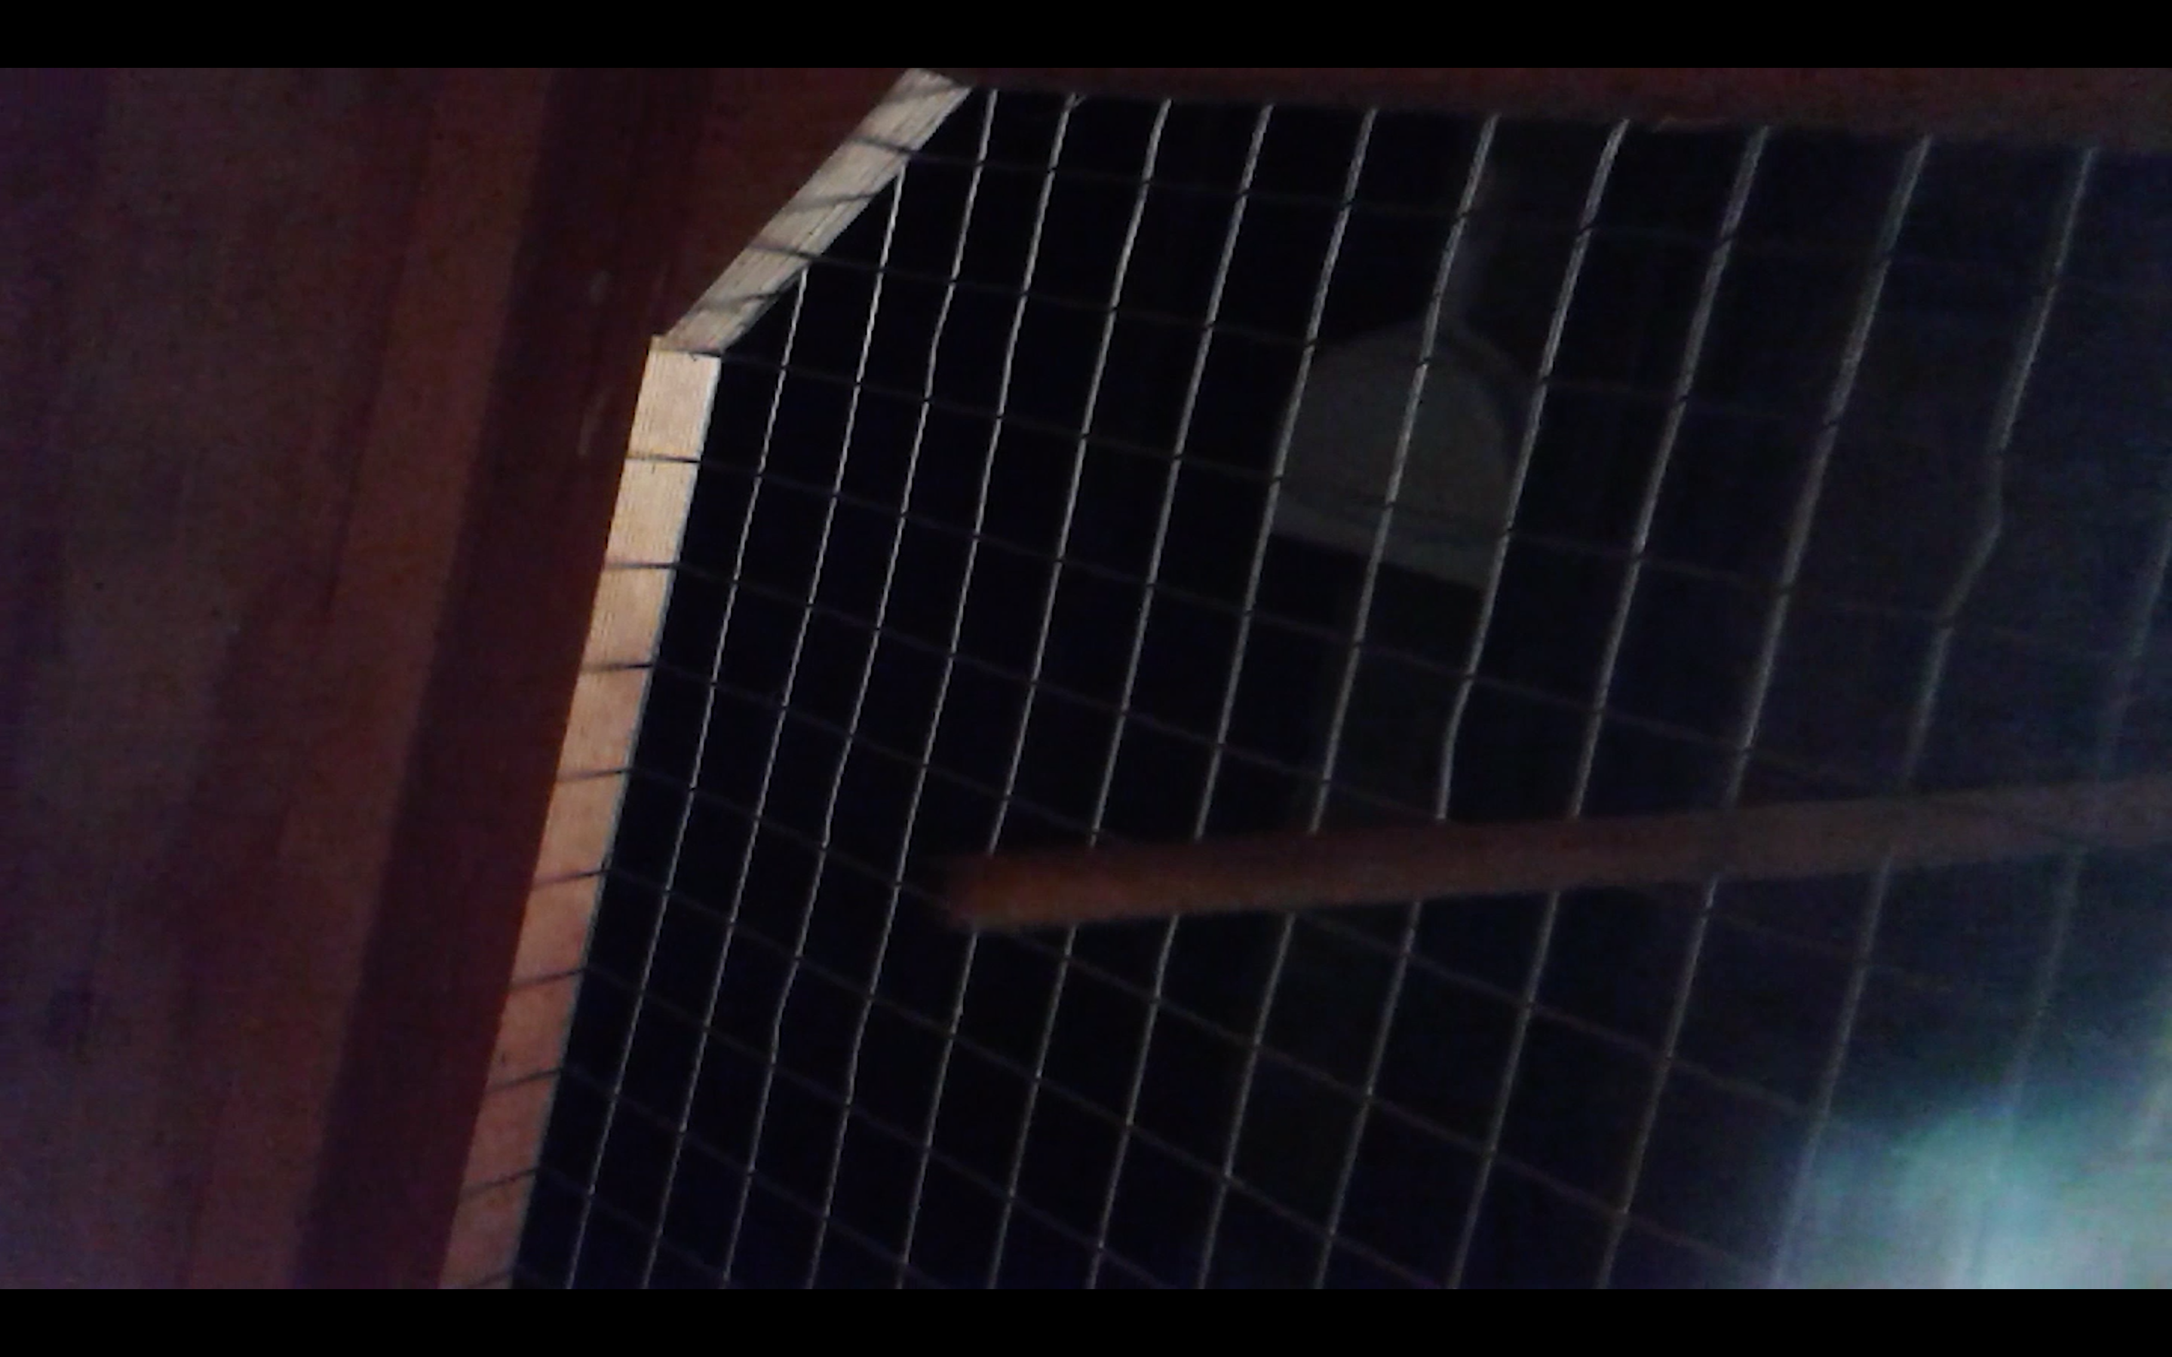

Sandy, 2015
Esmeralda Valencia Lindström
Cat-cam video, 5min, English dubbed in Italian.

-Sandy!

-Sandy!

-Sandy?

-Sandy.

-Sandy!

-Sandy!

-Sandy...

